Unit 75: IN A TOWN OR CITY
This unit gives you examples of across, along, around, at, behind, between, in, in front of, into, next to, on, opposite, out of, outside, past, around and to when we are talking about places in a town or city. The street plan below can help you to understand the examples.

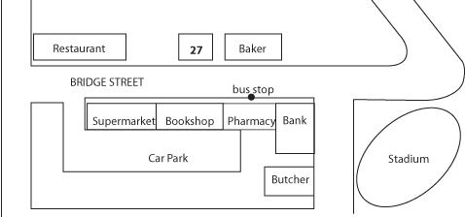
1
I live on Bridge Street / at 27 Bridge Street.
The pharmacy is next to the bank / opposite the baker / between the bookshop and the bank.
There is a bus stop outside the pharmacy/ the bus stop is in front of the pharmacy.
There is a car park behind the supermarket.
From the stadium, the restaurant is at the end of the street on the right.
2
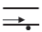 I walked along the road to the bank.
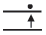 I walked across the road to the baker.

 I turned the corner onto Bridge Street.
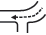 I turned the corner in Bridge Street.
 I turned left out of Bridge Street.
 We drove past the famous stadium.
 He ran around the stadium twice.
 I went around the corner to the butcher.
I went into town and walked around.
I did not go to any special place or in any special direction.

