Unit 74: IN THE WORLD
This unit gives you examples of a long way from, in, into, near, off, on, outside, through, to and towards when we are talking about places in the world.
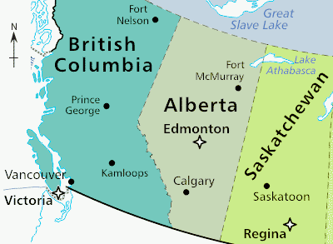
1 Look at the map of western Canada
Where do you live? in Victoria / in the province of British Columbia / on Vancouver Island / in the provincial capital city / on the coast / near the U.S. border
Where is Edmonton? in Alberta / approximately 300 kilometres from Calgary / near the centre of the province / outside of the mountains
Where is Regina? in the southern part of Saskatchewan / towards the U.S. border / a long way from Fort Nelson / to the south-east of Saskatoon
Where is Lake Athabasca? running through a provincial border / into Alberta and Saskatchewan / near Fort McMurray
2 Look at the diagrams
 She is moving to Calgary to find work.
It took four hours to get from Edmonton to Calgary.
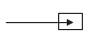 We drove into Saskatoon and found a place to eat.
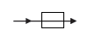 We got through Kamloops without asking for directions.
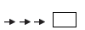 Bad weather is moving towards Victoria and the coast of British Columbia.

NOTICE:
By the year 2050, it is estimated that there’ll be up to 9.4 billion people in the world.
By the year 2050, it is estimated that there’ll be up to 9.4 billion people on the earth.

